**Associate Data Analyst in SQL DataCamp**

**Course 7: Introduction to Statistics**

**Summary Statistics**

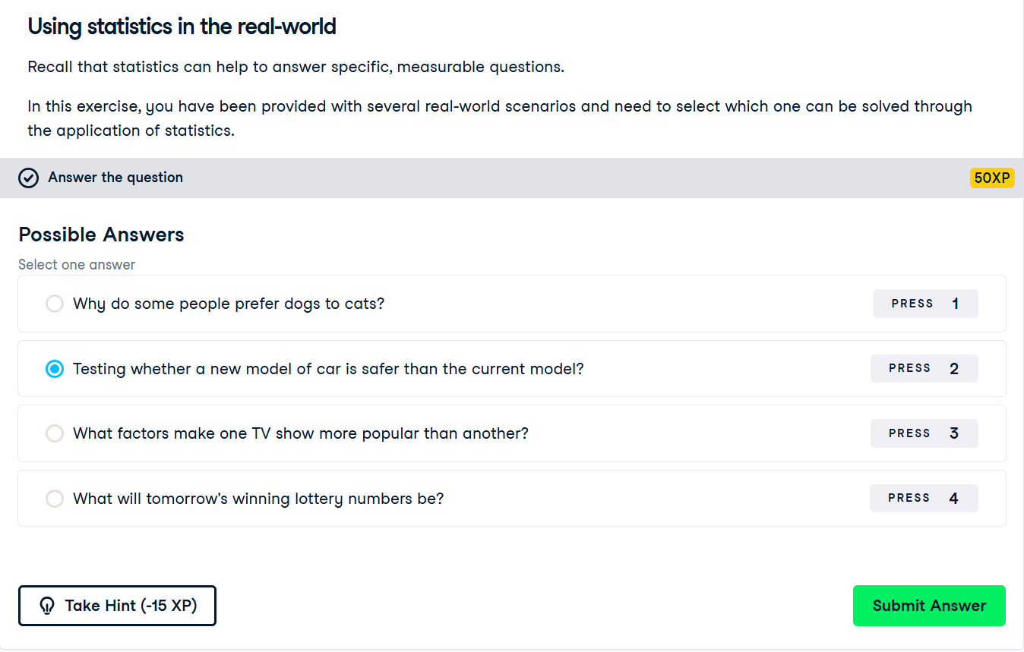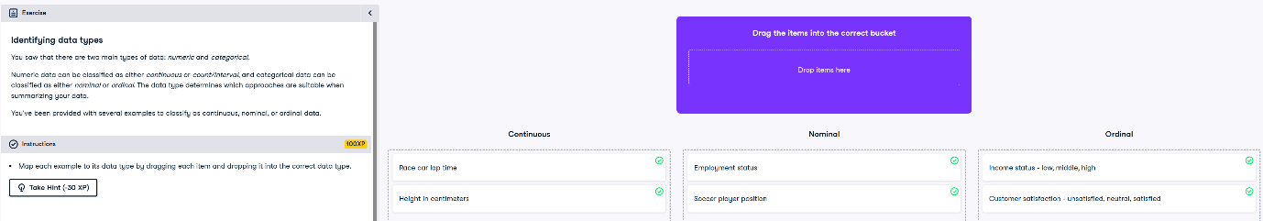

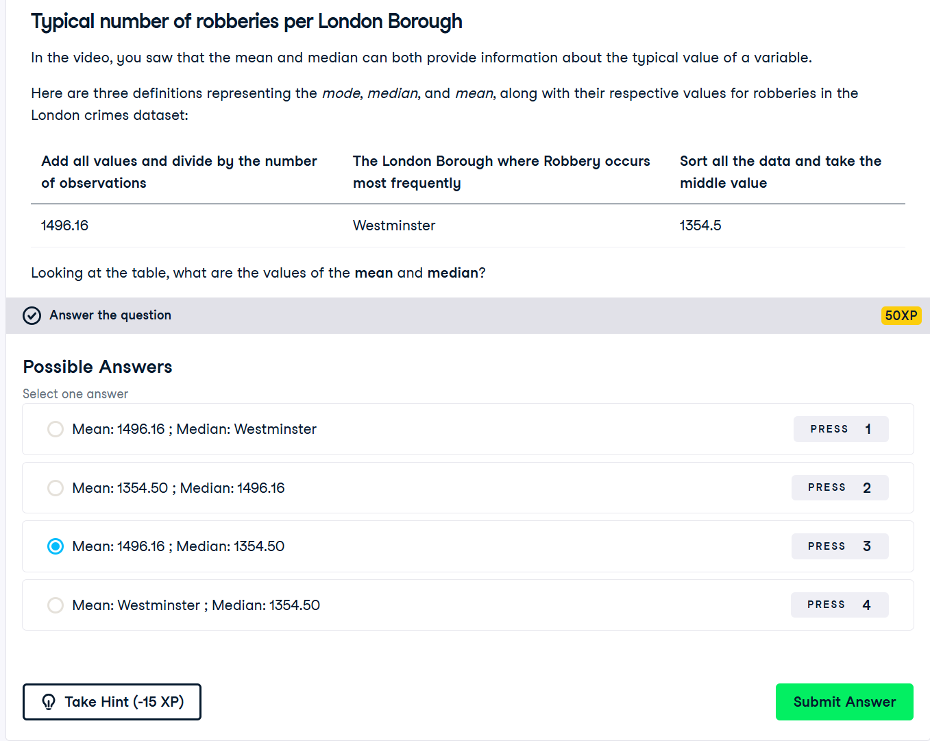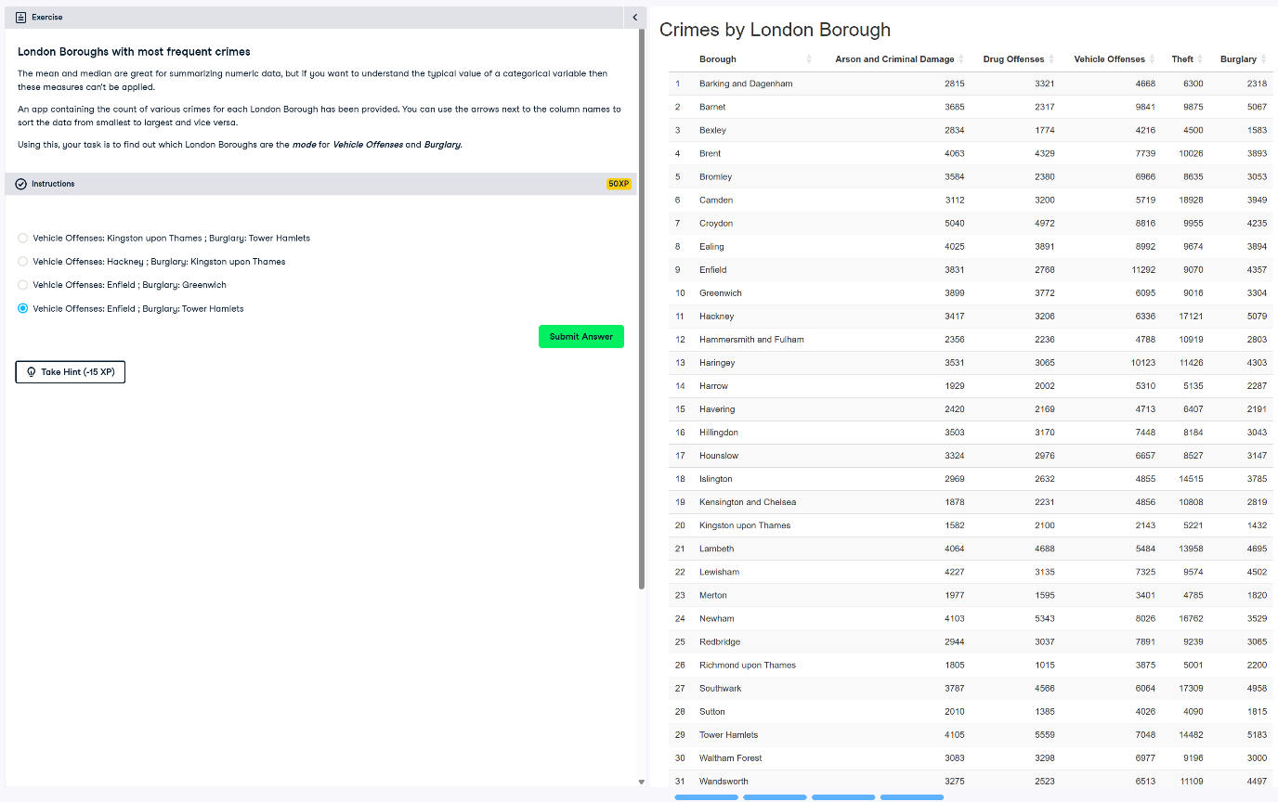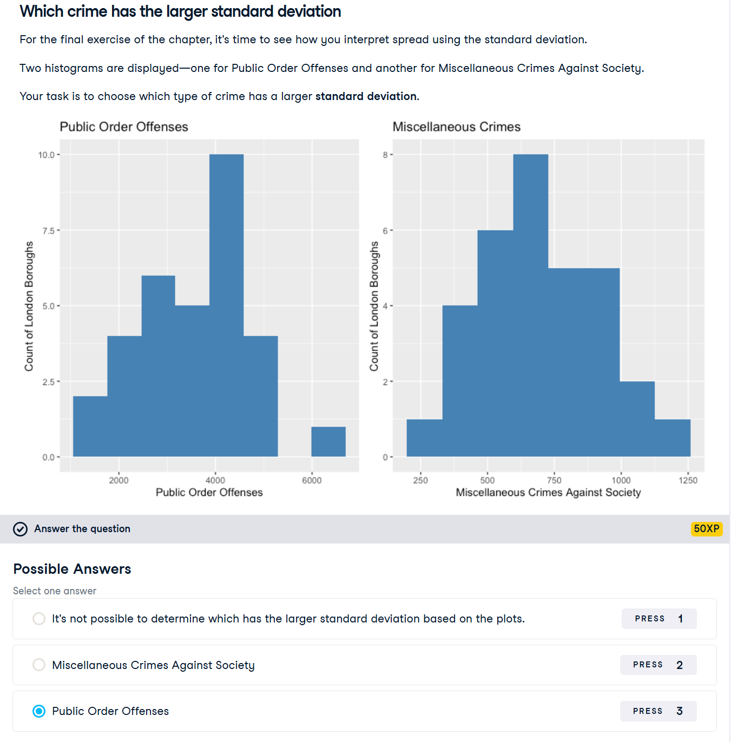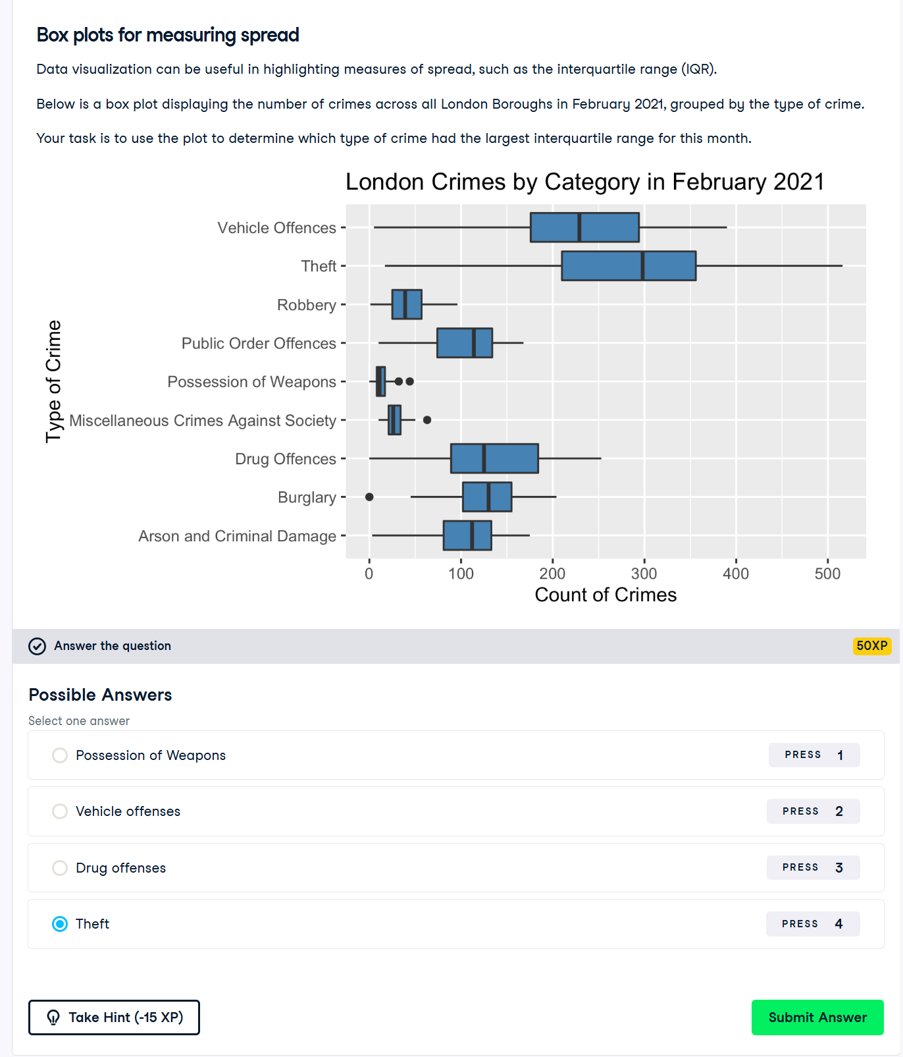

**Probability and distributions** 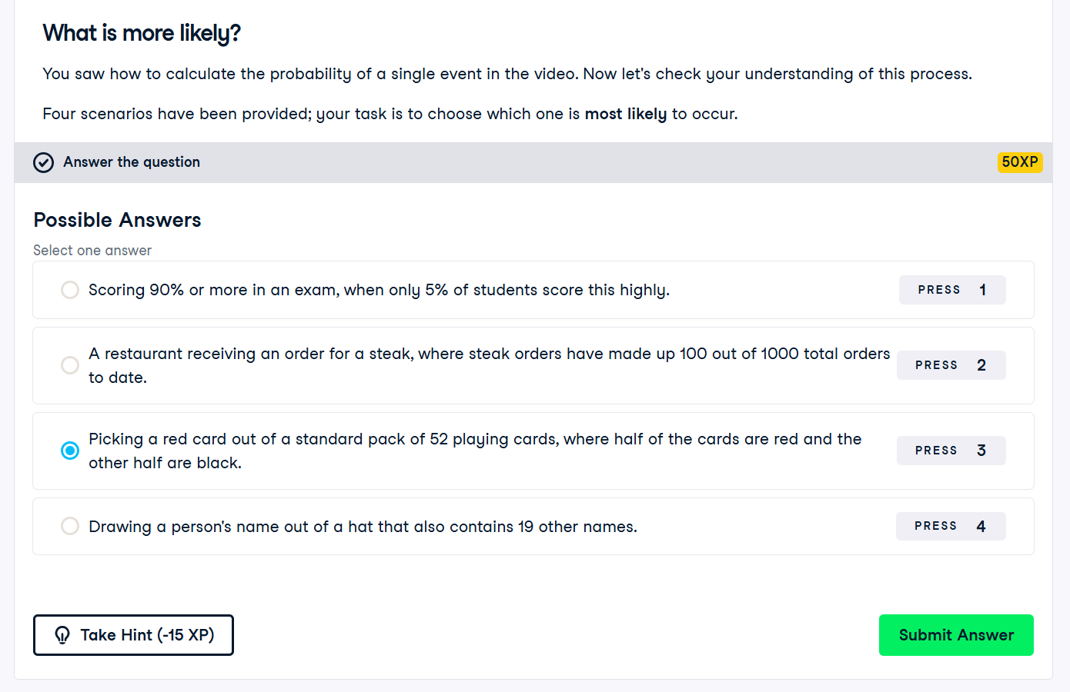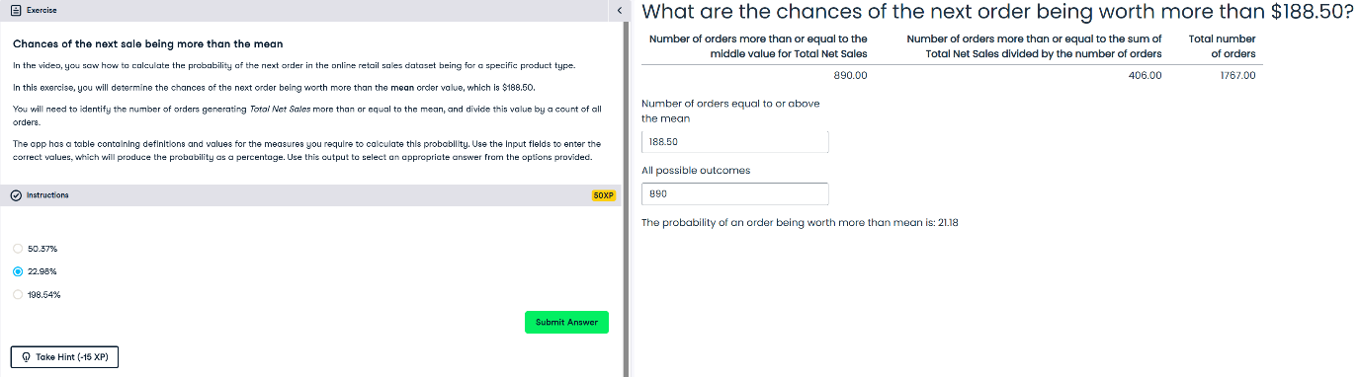

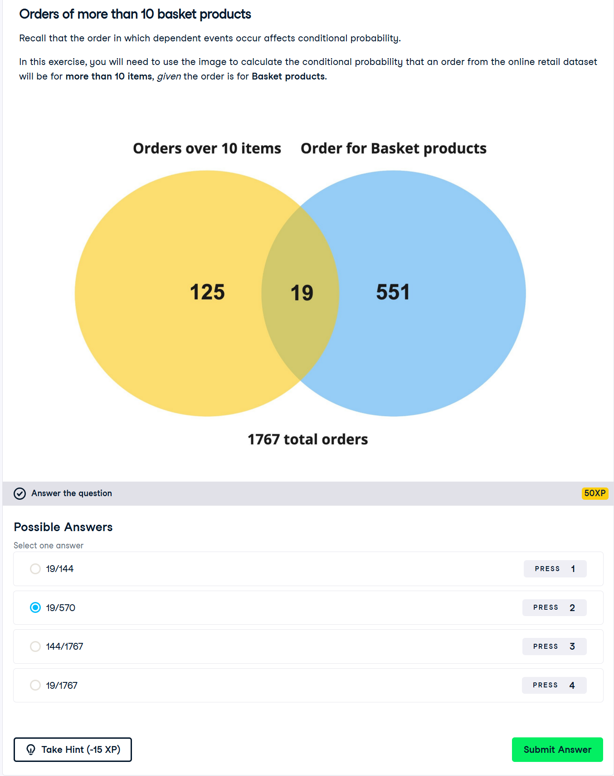

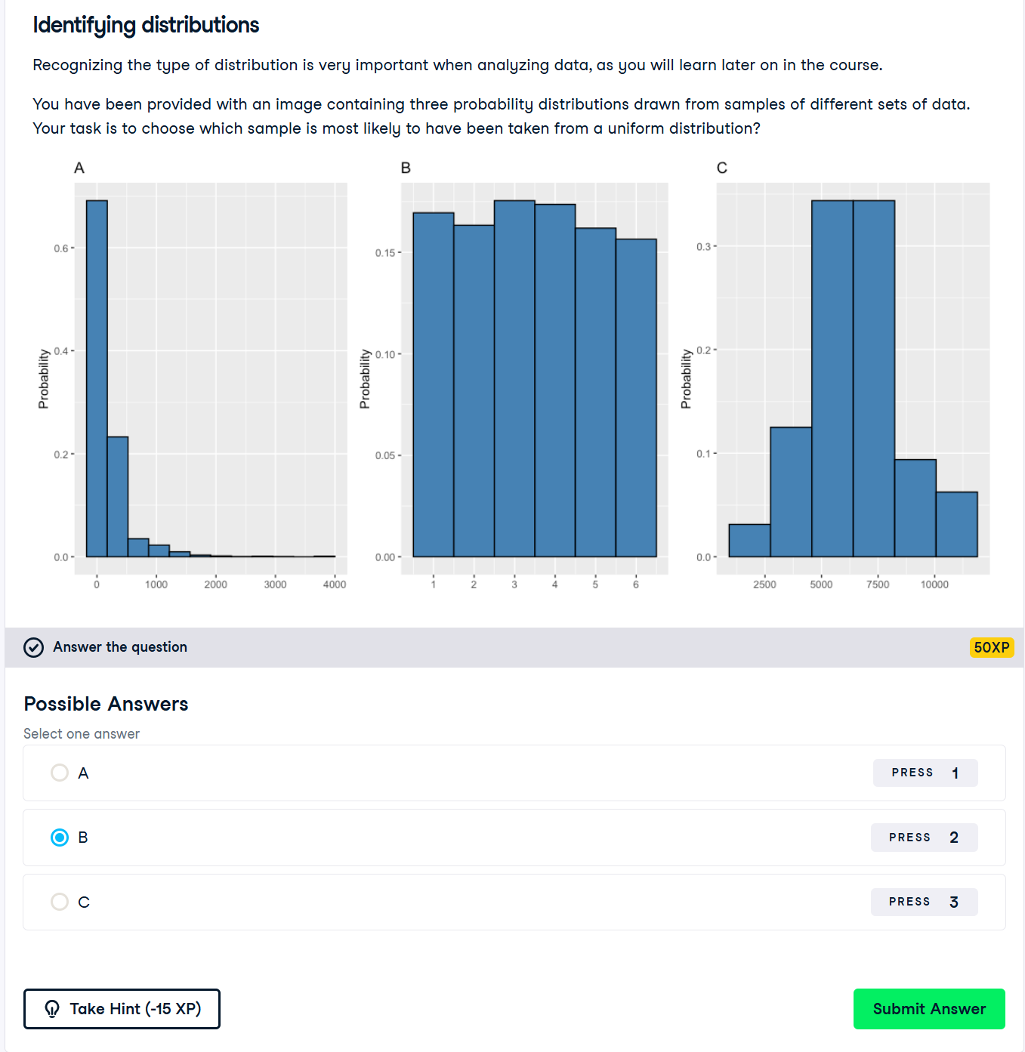

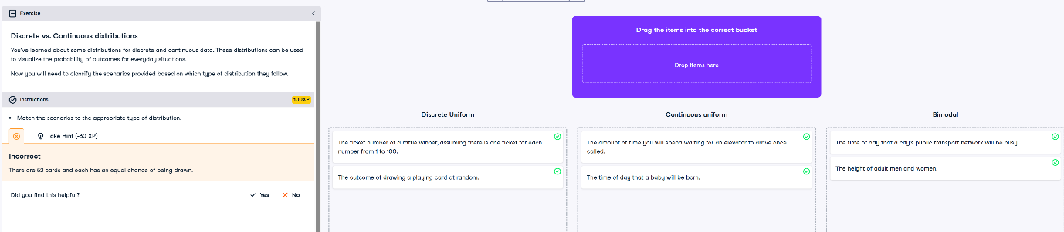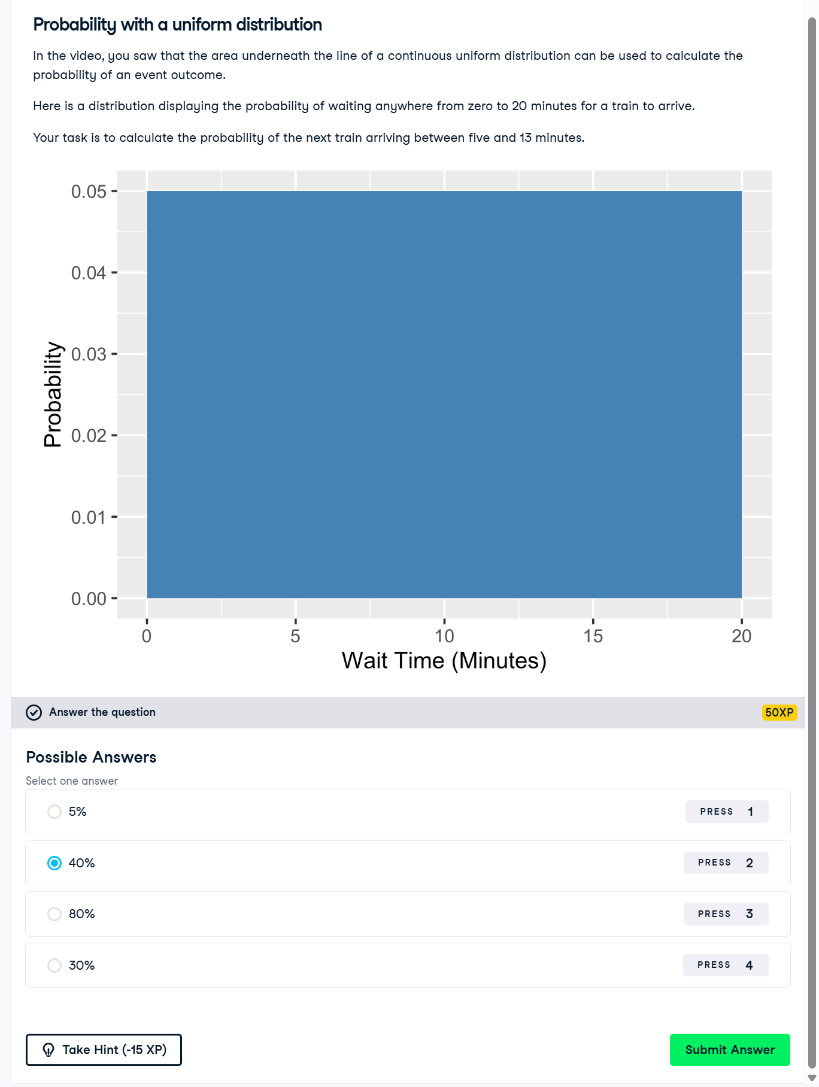

**More Distributions and the Central Limit Theorem** 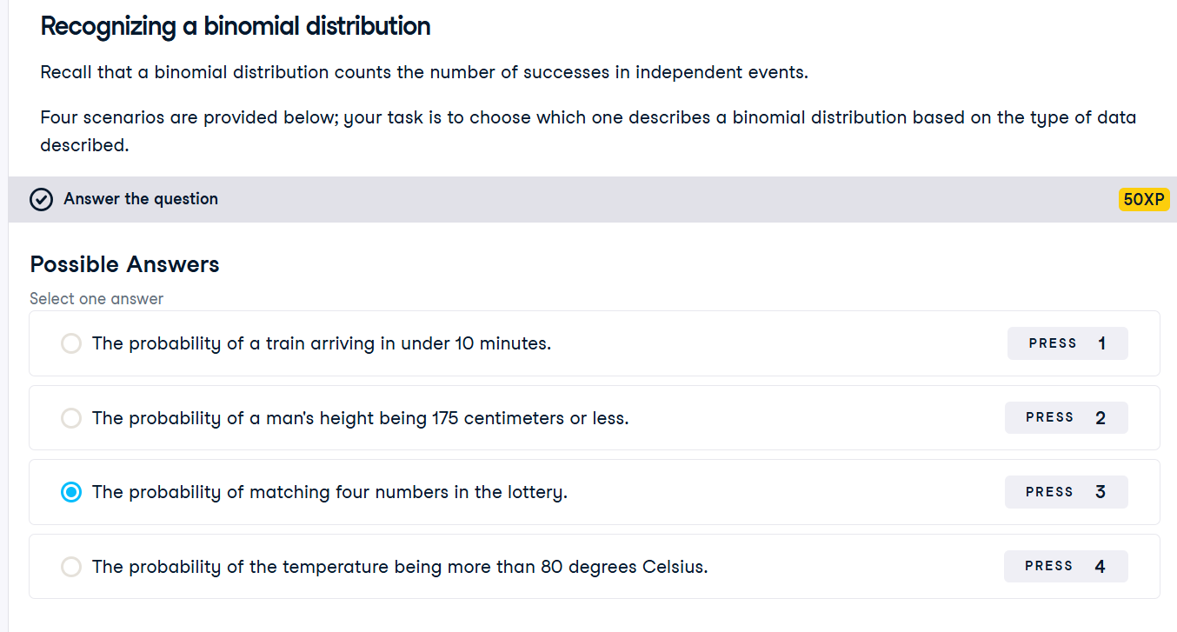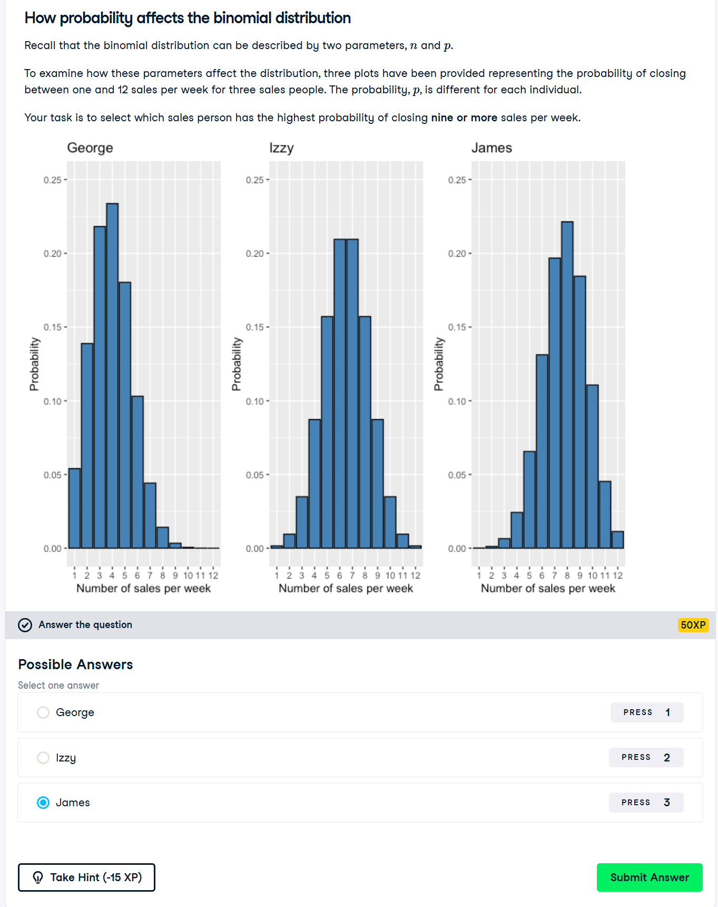

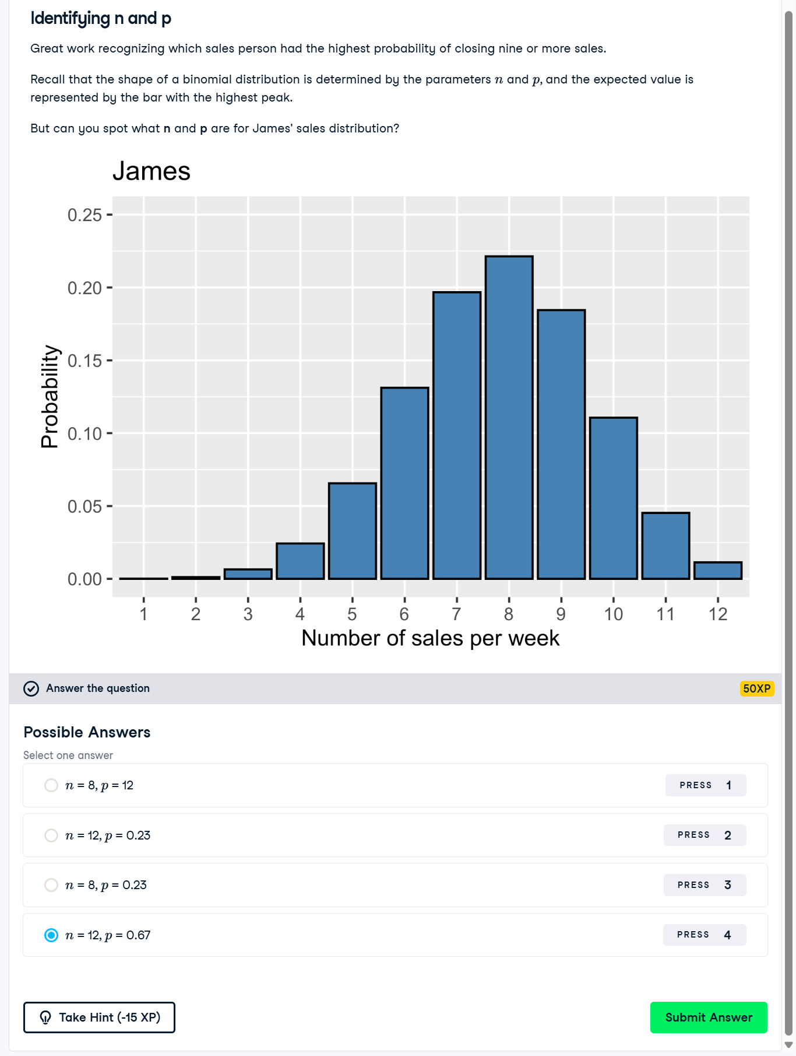

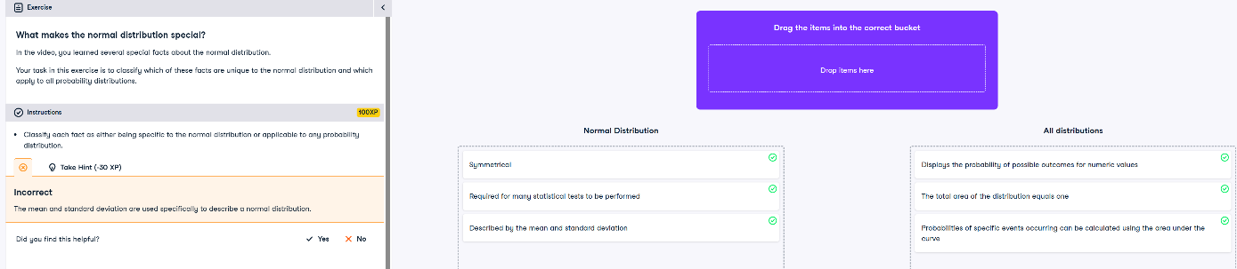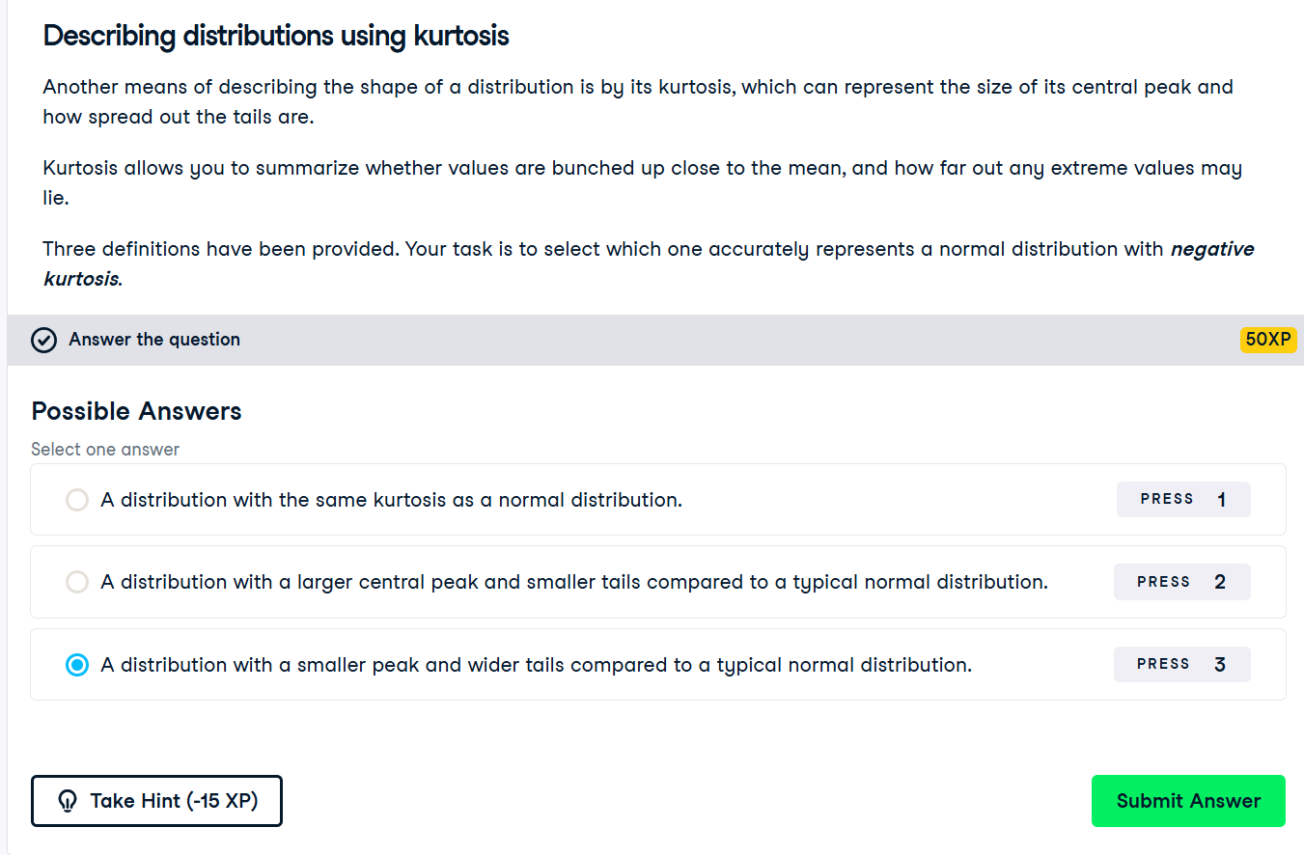

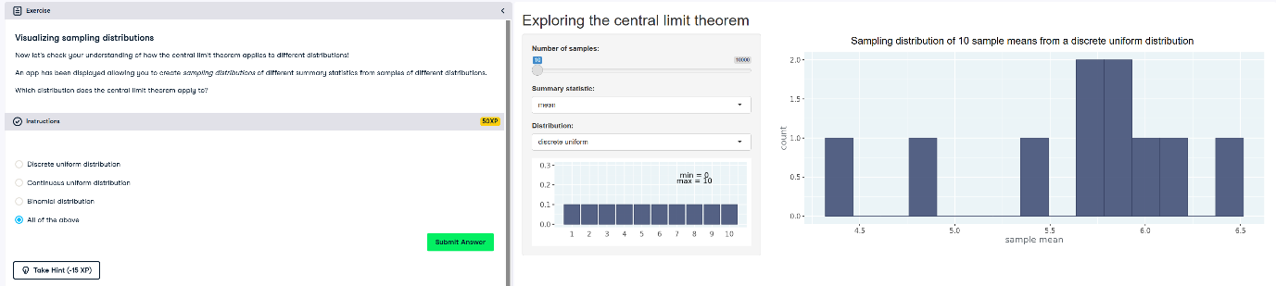

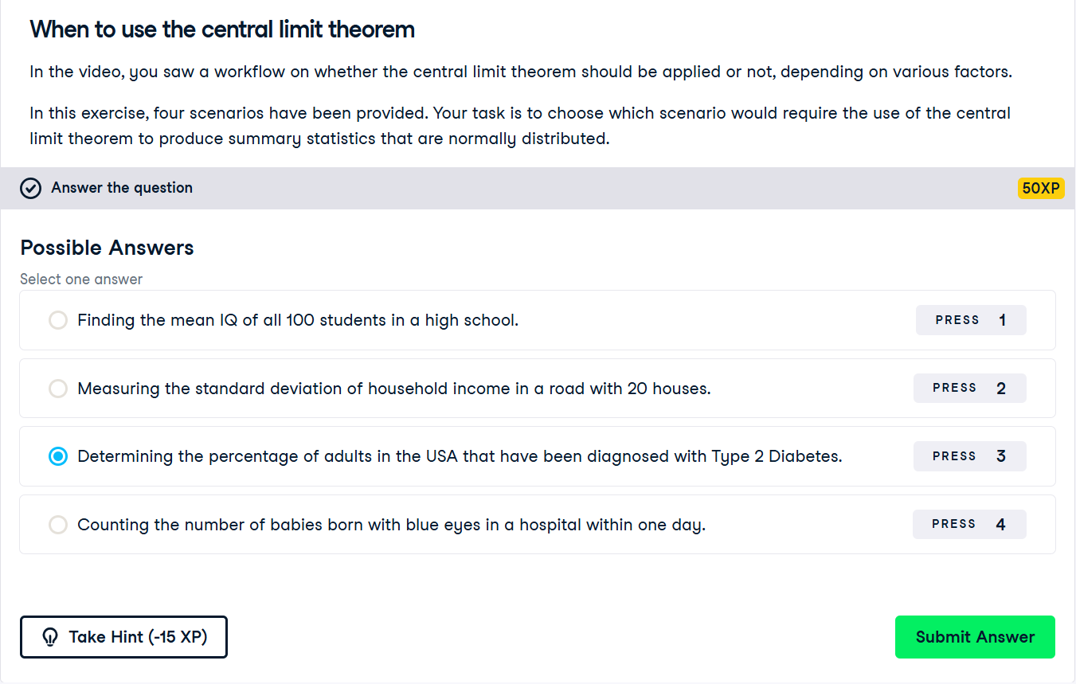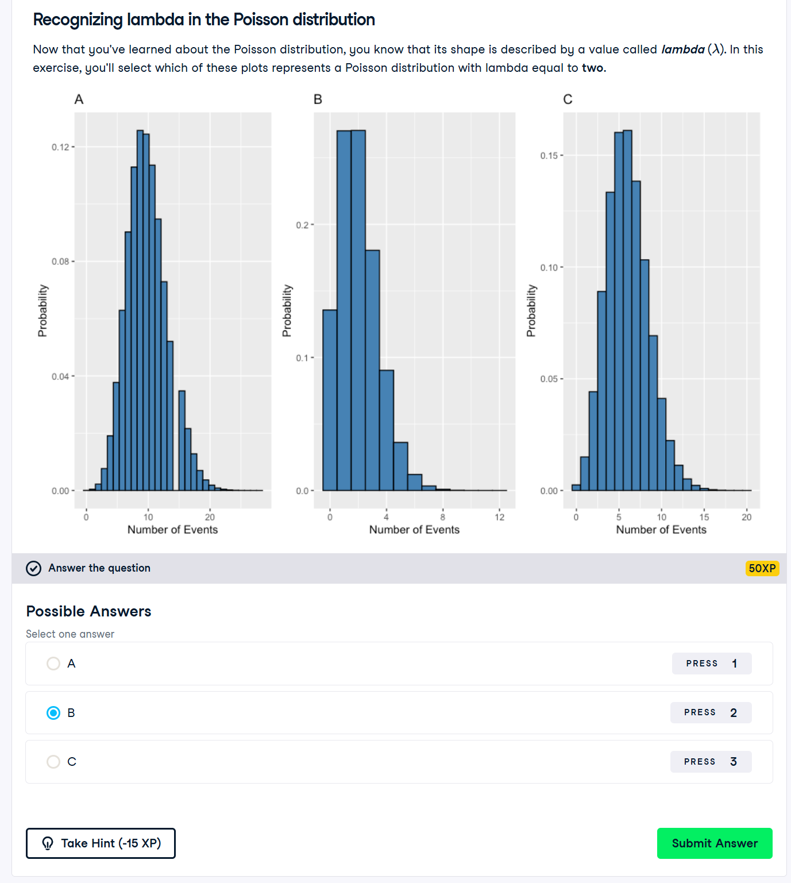

**Correlation and Hypothesis Testing**

